|  |  |
| --- | --- |
| **Key Points:**  **Look at both sides of the discussion topic** | **Research/ Notes** |
| Research topics found on ‘Climate change is real’  Include a minimum of three discussion points |  |
| Research topics found on ‘Climate change is fake news’  Include a minimum of three discussion points |  |
| What is your personal opinion |  |
| Plan how to interject and redirect the discussion  See pointers below |  |

**Interjecting**

**1. Interjecting to ask for clarification**

If you want the person you are talking with to give you a **longer explanation or additional detail**,

it’s perfectly okay to interrupt them to **ask for clarification**.

**This can help keep the conversation on topic; it also shows that you’re listening.**

Here are some useful phrases for **interjecting to ask for clarification**:

• Sorry, but could you go over that again?

• Sorry, but would you mind repeating that?

• Excuse me for interjecting, but I’m not sure I follow. Could you repeat that?

• Sorry for interjecting, but I’m not sure what you mean. What was that again?

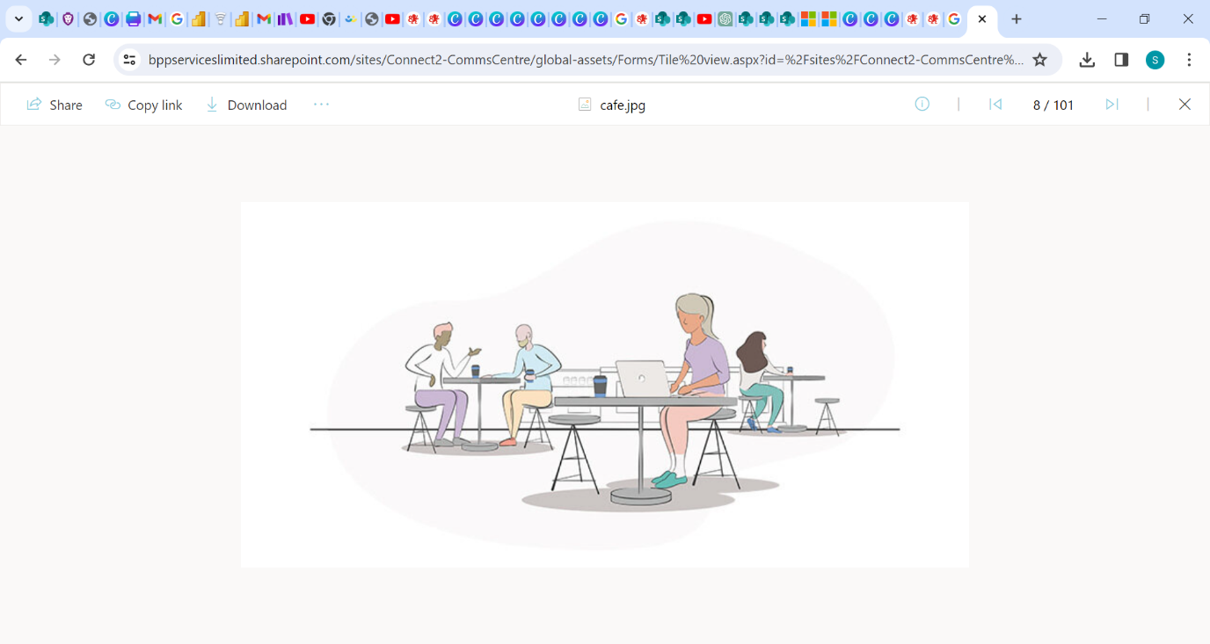

**2. Interjecting to agree with the other person**

This encourages the person talking to keep talking about this specific topic. Here are some examples:

• I agree

• I also thought … was disappointing.

• I don’t understand…either

If he or she is talking about a **personal experience, emotions, or feelings that you’ve also shared**, you can use one of the following expressions:

• I can relate.

• I know how you feel.

• I know what you mean; I also find that…

**3. Interjecting to show interest and enthusiasm**

If you are in a conversation where the person is mentioning something you’re intrigued by, interested in, or otherwise enthusiastic about, you can interject with a comment to briefly share your opinion.

This shows the person you care what they are talking about. Use one of these **expressions to show interest**:

• Thank you for sharing; I find that interesting to hear.

• I’ve wanted to know more about…

• I’m curious how…

• I’m interested in hearing more…

**4. Interjecting to mention something similar that you’ll talk about later**

If you want to share something similar, it’s okay to say that they’ve sparked something for you and

that you’ll **tell them more about it after they finish talking.**

• That reminds me…

• I also wanted to talk about...

• Let’s come back to that.

• As you were saying,….

• Remind me to tell you about my experience of…

This way you can go back to **listening carefully** to the other person.

**How Be Polite When Interjecting in Conversation**

Now that you understand when it is acceptable reasons to interrupt and interject a short comment,

question, or idea, let’s talk about how you can be especially **polite when interjecting**.

You may feel a little timid about jumping into the conversation while the other person is still talking.

Here are some **expressions** that you can use before interjecting your similar opinion or asking a question:

• Excuse me for interjecting, but…

• Can I add something?

• Can I say something here?

• Can I ask a question?

• Before you continue, I’d just like to add…

• I’d like to comment on that/say something/add something/remind you…

**Redirecting**

**1. Redirecting to Disagree with an Opposing Idea**

You could redirect a conversation to disagree with an idea. Here are some **expressions** that you could use to do this:

• I’d like to disagree with that statement…

• I have found contradictory evidence…

• The evidence that I have found opposes that view…

• My opinion differs…

**2. You can Redirect to Discuss Another Topic/Idea**

You could redirect a conversation to discuss new information. Here are some **expressions** that you could use to do this:

• I would like to discuss the evidence that I have found about…

• Another idea that would like to discuss is…

• Have you considered…

• May I share another idea?

**Remember that interjecting and redirecting is one of the skills that candidates must demonstrate to pass the Speaking and Listening assessment.**

**Contact-** [**FunctionlSkills@bpp.com**](mailto:FunctionlSkills@bpp.com)